**Feranmi Ayinde (F.A.)**

**City of Dilley Public Library**

<https://dilleylibrary.org/>

# **Table of Contents**

|  |  |
| --- | --- |
| 1. Context and Background ...........................................................................  2.1 Organizational Overview ................................................................................  2.2 Stakeholders .................................................................................................... | 5  5  5 |
| 2. Content and Metadata Analysis .................................................................  3.1 Benchmarking and Lessons Learned ...............................................................  3.2 Content Analysis ..............................................................................................  3.3 Metadata Analysis ............................................................................................ | 6  6  7  8 |
| 3. Usability Study ..........................................................................................  4.1 Personas ...........................................................................................................  4.2 Open Card Sorting ........................................................................................... | 101013 |
| 4. Usability Testing ....................................................................................... | 13 |
| 5. Sitemap ...................................................................................................... | 15 |
| 6. Wireframes ................................................................................................  7.1 Low-Fidelity Wireframes ................................................................................  7.2 Medium-Fidelity Wireframes .......................................................................... | 16  16  19 |
| 7. Content Map and Inventory .......................................................................  8.1 Content Map ....................................................................................................  8.2 Content Inventory ............................................................................................ | 21  21  22 |
| 8. Controlled Vocabulary .............................................................................. | 24 |
| 9. Drupal Prototype Information .................................................................  10.1 Drupal Screenshots ........................................................................................ | 29  30 |
|  |  |

# 

# **1. Context and Background**

## **1.1 Organization Overview:**

One of the main institutions in the thriving city of Dilley, Texas, is the City of Dilley Public Library. The library was founded with the goal of offering easily available resources and promoting a culture of learning. It functions as a center for literacy, education, and community involvement. With a vast selection of books, films, and online resources, the library serves a wide range of users, from young children learning the benefits of storytelling to people looking to learn and grow.

## **1.2 Stakeholders:**

* Library Patrons
  + The people who use the services of the City of Dilley Public Library for personal enrichment, pleasure, and education are its patrons, who come from a variety of backgrounds and ages. These stakeholders include adults using resources for professional growth, families looking for leisure reading materials, and kids seeking academic support.
* Local Residents
  + The influence of the library goes beyond its immediate users to the larger Dilley community. The library serves as a place for social events, meetings, and cultural gatherings for area residents. The library is also a great resource for locals looking for information about civic involvement opportunities, local history, and community services.
* Educational Institutions
  + The library is an important resource for helping children excel academically, working closely with local schools and educational institutions. The tools and activities offered by the library support classroom instruction, simplify research projects, and promote lifelong learning abilities among educators, administrators, and students alike.
* Community Organizations
  + The library works with a range of community organizations, including neighborhood clubs, nonprofits, and governmental bodies, to provide events, workshops, and programs that help locals of all ages. These events promote the library's goals of creating unity in society, cultural enrichment, and community involvement.
* Library Staff and Volunteers
  + The City of Dilley Public Library's volunteers and employees play an important part in providing the community with excellent facilities and programming. Their knowledge, experience, and passion for reading and education influence the library's operations and strategic orientation, keeping it an active and adaptable organization.

It is crucial to take these stakeholders' different needs, interests, and expectations into account while updating the library's website. The new website will improve accessibility, usability, and user experience by prioritizing user-centered design concepts and considering comments from a variety of user groups. This will improve the library's position as a valued resource and asset to the community.

# **2. Content and Metadata Analysis**

## **2.1 Benchmarking and Lessons Learned:**

|  |  |  |  |
| --- | --- | --- | --- |
| Website | Dilley Public Library | Dallas Public Library | Beloit Public Library |
| Organization | It is quite a simple layout that is overall easy to follow, but the website is so barebones that it would be difficult to get lost to begin with. | Good organization with lots of depth; website jumps between the “home” page and different parts of the website where it features a “catalog” and a “library market”, offers social media links on every part where the user stays on the “home” page. | Well organized and easy to access content with some amount of depth under the different pages. At the bottom of every page are social media links and an address that lists where the library is. |
| Navigation | Only global navigation, there isn’t really a “top-down” or “bottom-up” hierarchy, as clicking on the headers just leads to their respective pages. | There is global navigation and a bit of contextual navigation, but the global navigation is different depending on which part of the website the user is taken to. There is a top-down hierarchy for the headers, and there is a sitemap on both the “home” page and the “catalog” page. | Only global navigation with a top-down hierarchy, it’s possible there is some contextual navigation, but it’s not easy to tell. |
| Labeling | The labeling is pretty good, as the words chosen accurately describe the content on the webpage that is brought up. | Accurate labeling with no confusion brought by the words chosen. | Labeling is fairly good, with only one or two labels that could be changed to make it easier for the User to understand. |
| Search | No search system at all. | There is a search system that does allow for advanced searches, but it is hard to tell if Boolean operators are allowed for the search system, as the results sometimes match up with what I want and other times don’t. | There is a search system, but it looks like it only searches up regular terms, and there are no advanced search options available. Not even Boolean operators. |
| Usability | Functionally, the website will give you a minimal amount of information that may be needed, but it can be used only under the guise that you know exactly what you want from the website. With those in mind, the website overall has poor usability because of its lack of a search system and bare-bones aesthetic. | This website has great usability because of its ease of navigation, a good labeling system, and overall great organization, with the search system being the only part that left something to be desired. | A fairly usable website overall, as the organization is good enough to where the users will understand where to go and the navigation systems will take them where they want to go, but a poor search system and a few confusing labels will lead Users wanting. |

## **2.2 Content Analysis:**

(C.K.)

The website for the Dilley Public Library is designed for an audience who wants to check out not only what the library offers through their catalog located on a separate website, but also potential events, their child programs, as well as ways to contact the library staff.   
  
The existing website shows that the website overall will need a big overhaul of their current organization scheme, as it is a hybrid scheme of both topic and task, with a nonexistent hierarchy due to the simplicity of the website itself. The current labels work well enough so those will not be changed, but overall, we will have to add a hierarchy, most likely top-down, so that way the users can find their information more easily. In the site, we will have to consider the current labels and make sure they still fit correctly into the new organization scheme, so that it can be a seamless transition from one to the other. Based on what we have seen from this website, it is hard to tell if it really needs local navigation based on what the competitor’s websites had to offer, but we will be sure to add in contextual navigation so they will lead to informative web pages or just to other webpages in general.

The current website features 1) Home, 2) Contact Us, 3) Services, 4) Resources, 5) Children Programs, and 6) Picture Gallery, with no subcategories to be found on any of the categories.

On every page is the title “City of Dilley Public Library,” and it features the 6 previously mentioned categories, with the phrase “Copyright © 2018 dilleylibrary.org - All Rights Reserved.” and “Powered by GoDaddy”. The website features mostly just documents and bits of items that tell the user about the information that they clicked on when they choose a category. Under the “Home” category, there is a photo of a library with a section called “About Us” that tells the users “Our Mission,” “Our Goals,” and “Our Staff,” with another section below that listed as “Events,” where now there are no events listed. Under “Contact Us” is a form the User fills out to contact the library, with the rest of the page listing not only a phone number, but also the hours that the business is open. Under “Services,” is a list of helpful amenities that is offered to those who go to the library in person. Under “Resources” are several links to other websites such as their public library catalog, the Lone Star Digital Library, the Tex Share Databases, the Frio Current and Dilley Herald Past Issues, as well as links to the Dilley and Pearsall Independent School District websites. Under “Children Programs” are two programs listed as “After School Program” and “Summer Reading Program,” with descriptions of both programs listed underneath. Lastly under “Picture Gallery” is a slideshow picture gallery titled “Photo Gallery,” which shows the Users photographs taken at the library.

## **2.3 Metadata Analysis:**

|  |  |  |  |  |
| --- | --- | --- | --- | --- |
| **Metadata for Dilley Public Library** | | | | |
| Title | Our Staff | Our Mission | Our Goal | Hours |
| Type | Webpage Content | Webpage Content | Webpage Content | Webpage Content |
| URL | [https://dilleylibrary.org](https://dilleylibrary.org/) | [https://dilleylibrary.org](https://dilleylibrary.org/) | [https://dilleylibrary.org](https://dilleylibrary.org/) | [https://dilleylibrary.org/contact-us](https://dilleylibrary.org/) |
| Description | Ashlan Salinas  Library Director  Maria Gauna  Library Clerk  116 East Miller Street  Dilley, Texas 78017  (830) 965-1951 | The Mission of the Dilley Public Library is to promote, coordinate and facilitate communications and resource sharing to provide quality library information and services to all residents in the community and the surrounding area | Improve the collection of the library in quality and accessibility.  Enhance the level of expertise in providing quality library services.  Develop library programs to serve the residents of the community.  Promote the sharing of informational education and cultural resources*.* | Monday - Friday: 8am - 5pm  Saturday - Sunday: Closed |

|  |  |  |  |
| --- | --- | --- | --- |
| **Metadata for Dilley Public Library** | | | |
| Title | Events | Our Services | Library Resources |
| Type | Webpage Content | Webpage Content | Webpage Content |
| URL | [https://dilleylibrary.org](https://dilleylibrary.org/) | <https://dilleylibrary.org/services> | <https://dilleylibrary.org/resources> |
| Description | No upcoming events. | In House Services  The Dilley library offers these services to the community and the surrounding areas:  Copy Machine Services  Fax Services  Computer Printouts  Free WiFi  Internet Services  Email Services | Dilley Public Library Online Catalog  Lone Star Digital Library  TexShare Databases  Frio Current and Dilley Herald Past Issues  Dilley Independent School District  Pearsall Independent School District |

|  |  |  |  |  |  |
| --- | --- | --- | --- | --- | --- |
| **Metadata for Dilley Public Library** | | | | | |
| Title | After School Program | Summer Reading Program | Photo Gallery | Home | Contact Us |
| Type | Webpage Content | Webpage Content | Webpage Content | Page Title | Page Title |
| URL | <https://dilleylibrary.org/children-programs> | <https://dilleylibrary.org/children-programs> | <https://dilleylibrary.org/picture-gallery> | [https://dilleylibrary.org](https://dilleylibrary.org/) | [https://dilleylibrary.org/contact-us](https://dilleylibrary.org/) |
| Description | The After School Program allows children to do their homework, utilize the computers and if time permits and there is enough supervision, they have Arts & Crafts. | The library has awesome reading programs every year for the children of the community and the surrounding areas. | No description only shows 11 photographs that relate to the library in some way. | Lists the mission and goals in the About Us and the coming events. | Gives the User the opportunity to contact the website while also listing the hours. |

|  |  |  |  |  |  |
| --- | --- | --- | --- | --- | --- |
| **Metadata for Dilley Public Library** | | | | | |
| Title | Services | Resources | Children Programs | Picture Gallery | Copyright |
| Type | Page Title | Page Title | Page Title | Page Title | Rights |
| URL | <https://dilleylibrary.org/services> | <https://dilleylibrary.org/services> | <https://dilleylibrary.org/children-programs> | <https://dilleylibrary.org/picture-gallery> | [https://dilleylibrary.org](https://dilleylibrary.org/) |
| Description | This page lists the services that the library offers to those going to their physical location. | This page lists the various resources that have something to do with either the original webpage, or just the public library in general (i.e., their catalog). | This page lists out the two programs that the public library has to offer. | This page shows various photographs of events that have happened at the public library. | Copyright © 2018 dilleylibrary.org - All Rights Reserved. |

# 

# **3. Usability Study**

## **3.1 Personas:**

**The first user information includes:**



“As a student the Dilley public Library provides me with resources to navigate through homework, projects and exams.”

**Background**-

Name: John Paul

Age: 18  
Location: Dilley, Texas

Family Status: Live with parent

Education: High school student

Income: Dependent on parent

Technology Proficiency: Comfortable with technology, utilizes several social media and online platforms for school and entertainment.

**Goals**-

* Primary goal: to access reliable and credible resources for assignments, major projects, and exams.
* Secondary goal: to secure a quiet space that is conducive for studying and group discussions.
* Needs: To access journals, books, and articles for preparation of advanced testing (ACT/SAT).

**Behaviors**-

* Utilizes the library’s online database and digital library for obtaining study materials and conducting research.
* Visits the library frequently to borrow materials and study.

**Challenges**-

* Problem finding a convenient place to meet with classmates outside of school, for group sessions.
* Limited access to useful study materials at home and school.
* Inability to focus due to distractions at home.

**How Dilley Public Library help serve his needs**:

* Equip him with access to computers and high-speed internet to facilitate online learning
* Offers quiet private room and study areas
* Hosts workshops, seminars and tutorials to support him with academics.

**The second user information includes:**



“I love learning new things during my down time and the Dilley Library provides me with adequate resources to cater for my needs.”

**Background-**

Name: Janet Park

Age: 35

Location: Dilley, Texas

Occupation: High School Teacher

Family Status: Married, with three kids

Education: Master’s in English Literature

Income Range: Middle class

Technology Proficiency: Comfortable with basic technology, uses smartphone and laptop.

**Goals**-

* Primary goal: To locate child-friendly books so she can read to her kids
* Secondary goal: To access professional resources and teaching guides that could strengthen her teaching skills.
* Needs: a quiet space to study, grade and plan lessons.

**Behaviors**-

* Provides her students with community and school events opportunities.
* Uses the library’s online catalog to reserve books.
* Visits the library weekly to participate in children’s programming.

**Challenges-**

* Struggle to make time for research, due to busy schedule
* Adapting to constant change in curriculum and teaching strategies.
* Inability to focus on work while the kids are around.

**How Dilley Public Library help serve her needs**:

* Provide access to several professional resources including teaching guides and literature.
* Liberians assist Janet in selecting books that suites her and her children’s needs.
* Provide Janet with a community room for hosting book clubs with her students.

## **3.2 Open Card Sorting:**

Below is a link to the open card sorting study for the Dilley Public Library. This survey includes 20 cards and the limit for viewable participants is 10

<https://dljzks4z.optimalworkshop.com/optimalsort/6ef45b7aacd74c4bc285fcd3d77c2683>

# **4. Usability Study**

**Open Card Sorting Study**

For the open card sorting activity, we were able to acquire up to 9 different participants from different backgrounds, with unique needs. These individuals include students, teachers, researchers, and company employees.

Below is a link to the conducted survey:

<https://app.optimalworkshop.com/optimalsort/dljzks4z/6ef45b7aacd74c4bc285fcd3d77c2683/shared-results/6gfqhc0v6em0byqm9hzxrc89ydiourei>

Here are the results from the survey:

**About Us**

* Library hours
* About the library
* Contact info
* Donation information

**Library Services**

* Homework help
* Career development resources
* Study rooms reservation
* Navigation services
* Research database

**Library Events**

* Teen programs
* Community events
* Adult learning
* Children programs
* Volunteer Opportunities

**Accessibility**

* Computer and WIFI access
* Printing and photocopy services
* Accessibility services

**Photo Gallery**

* Art exhibits
* Gallery
* Online Catalog

This survey included 20 cards in which participants can create groups based on how they feel the website should be designed. The result showed that 9 out of 27 (33%) completed the survey, while 18 abandoned. The median time it took participants is 10 minutes 3 seconds, the longest time was 45 minutes 44 seconds, and the shortest time was 5 minutes 30 seconds. 11% of the participants created 3 categories, 44% created 4 categories, and 44% created 5 categories.

Looking at the survey results, it can be concluded that most participants opted to create at least 5 different groups, including the information they deemed important on each of the groups. The 5 groups most participants created include About Us, Library Services, Library Events, Accessibility, and Photo Gallery.

By incorporating the results from this survey and the information that already appeared on the Dilley Public library website, we have decided to redesign the website leaning heavily on the categories recommended by the participants, as this would make the website more effective since it came from potential users of the site.

# **5. Sitemap**

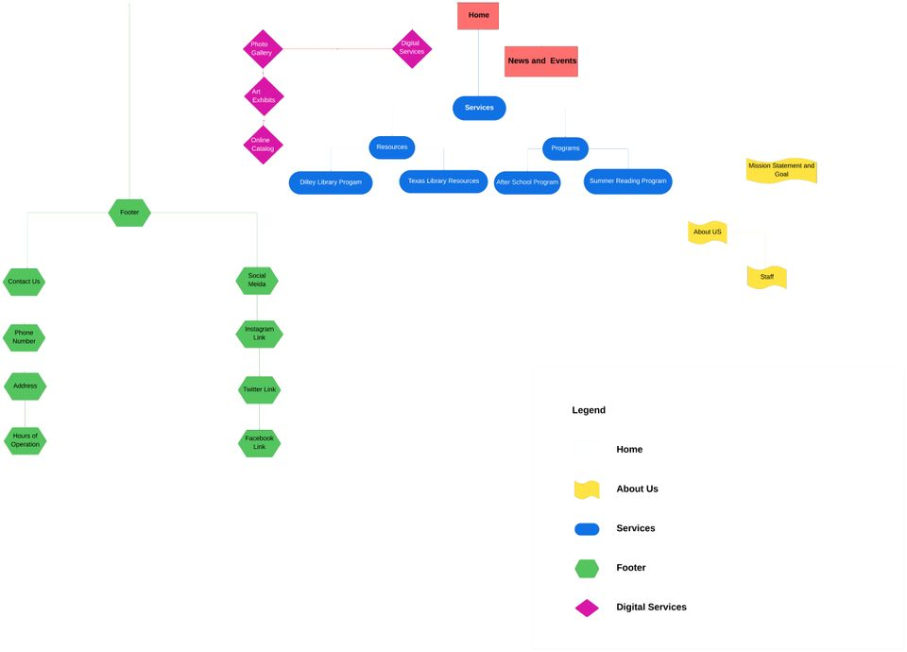

# 

# **6. Wireframes**

## **6.1 Low-fidelity Wireframes:**

**Home Page**

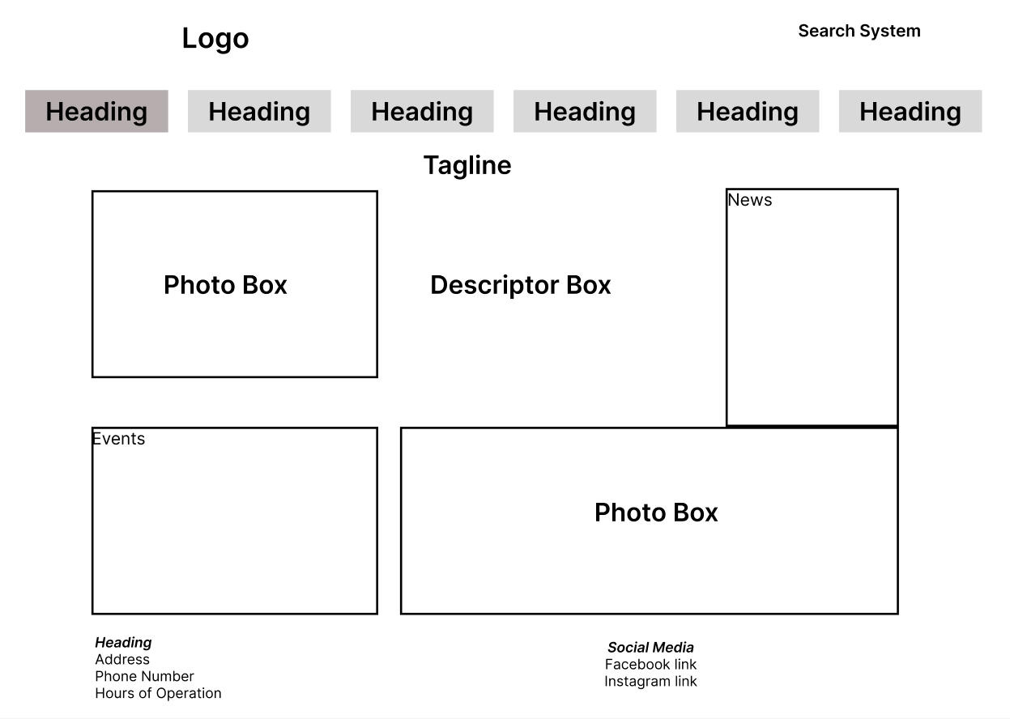

**Services Page**

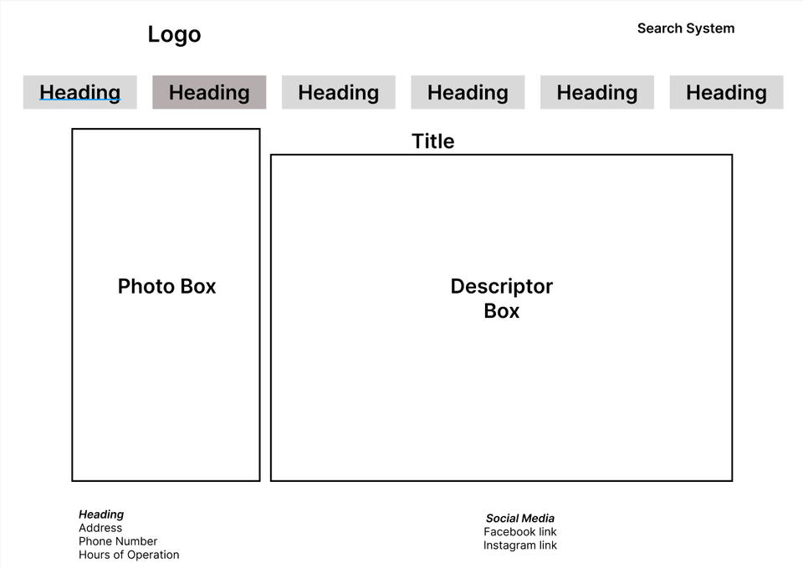

**Photo Gallery Page**

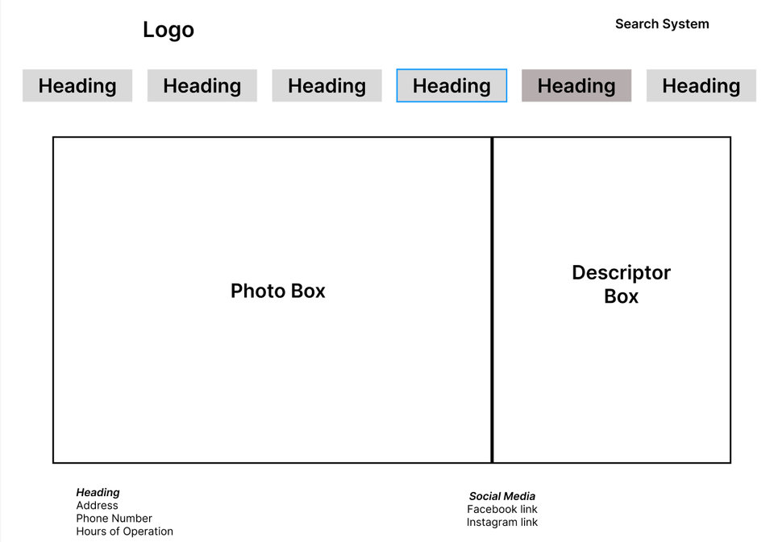

## **6.2 Medium-fidelity Wireframes:**

**Home Page**

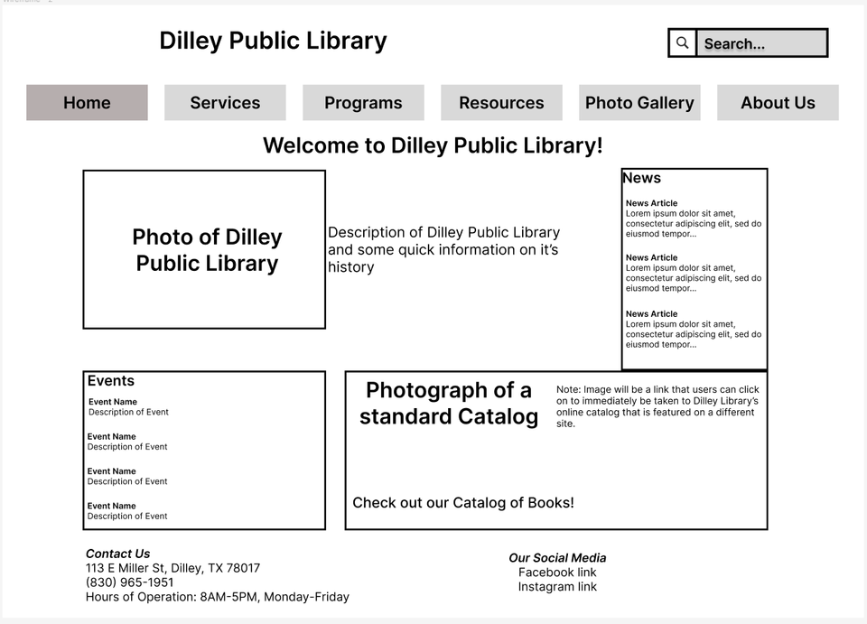

**Services Page**

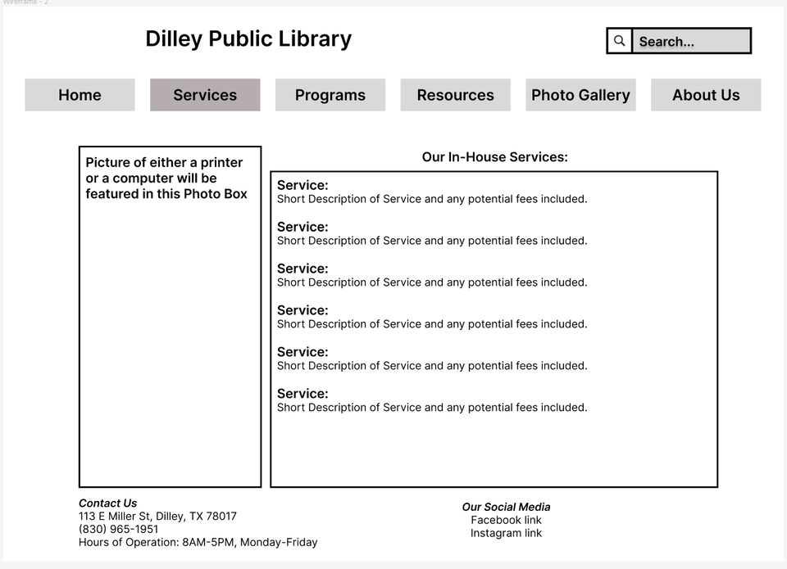

**Photo Gallery**

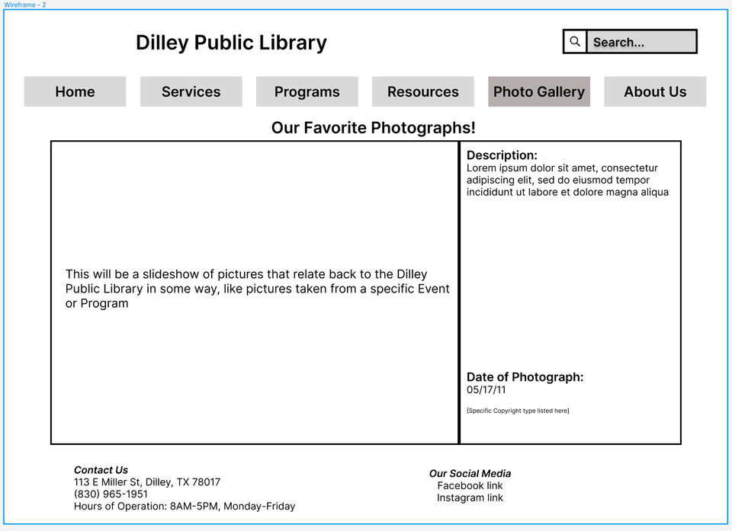

# **7. Content Mapping and Inventory**

## **7.1 Content Map:**

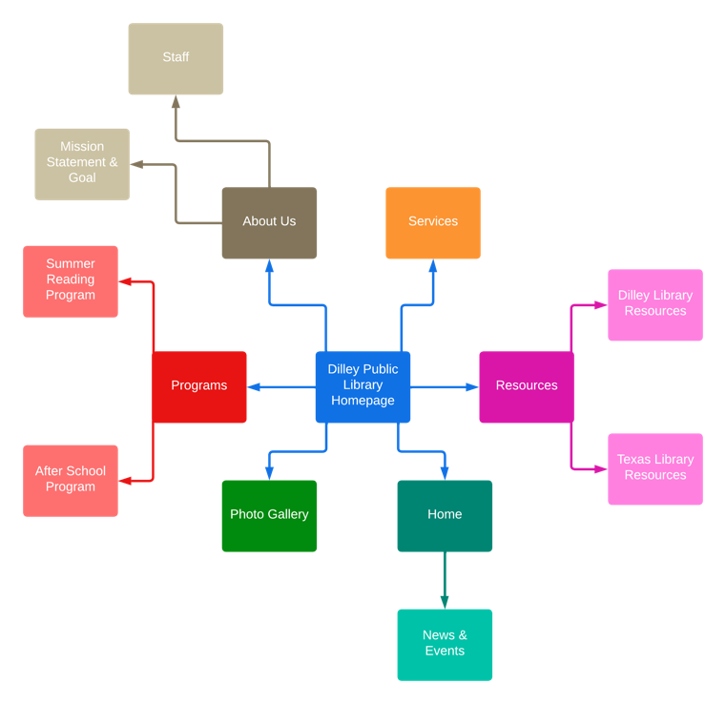

## **7.2 Content Inventory:**

|  |  |  |  |  |
| --- | --- | --- | --- | --- |
| Page ID Number | Page Title | URL | Location | Content |
| 0 | Home | <https://dilleylibrary.org/> | **Home page** | Page title  Links to About Us, Services, Resources, Photo Gallery, Programs |
| 1 | About Us |  | **First level page**  Linked from Home page | **Page title**  Staff  Mission Statement & Goal |
| 1.1 | Staff |  | **Second level page**  Linked from About Us | List of staff members and their contact information |
| 1.2 | Mission Statement & Goal |  | **Second level page**  Linked from About Us | Library’s goal and mission statement |
| 2 | Services | <https://dilleylibrary.org/services> | **First level page**  Linked from Home page | **Page title** |
| 2.1 | Copy Machine Services |  | **Second level page**  Linked from Services |  |
| 2.2 | Fax Services |  | **Second level page**  Linked from Services |  |
| 2.3 | Computer Printouts |  | **Second level page**  Linked from Services |  |
| 2.4 | Free WiFi |  | **Second level page**  Linked from Services |  |
| 2.5 | Internet Services |  | **Second level page**  Linked from Services |  |
| 2.6 | Email Services |  | **Second level page**  Linked from Services |  |
| 3 | Resources | <https://dilleylibrary.org/resources> | **First level page**  Linked from Home page | **Page title**  Dilley Library Resources  Texas Library Resources |
| 3.1 | Dilley Library Resources |  | **Second level page**  Linked from Resources | Resources provided by the Dilley Library |
| 3.2 | Texas Library Resources |  | **Second level page**  Linked from Resources | Resources provided by the Texas Library |
| 4 | Photo Gallery | <https://dilleylibrary.org/picture-gallery> | **First level page**  Linked from Home page | **Page title** |
| 5 | Programs | <https://dilleylibrary.org/children-programs> | **First level page**  Linked from Home page | **Page title**  Summer Reading Program  After School Program |
| 5.1 | Summer Reading Program |  | **Second level page**  Linked from Programs | Information on the summer reading program |
| 5.2 | After School Program |  | **Second level page**  Linked from Programs | Information on the after-school program |

# **8. Controlled Vocabulary**

|  |
| --- |
| **Legend** |
| USE: Use preferred term, preferred terms are listed in **Bold** |
| UF: Use For |
| BT: Broader Terms |
| NT: Narrower Terms |
| RT: Related Terms |

For our controlled vocabulary list, we decided to go with ERIC Thesaurus for our thesaurus, because after going through several thesauri, ERIC had the greatest number of terms within its database of terms. ERIC provided lots of broad, narrow, and related terms for each word we chose, helping greatly when building this list.

After School Program

USE **Programs**

Adolescents

USE **Children**

**Catalogs**

NT Online Catalogs

**Children**

RT Adolescents

RT Elementary School Students

**Computers**

UF Digital Computers

RT **Databases**

RT **Social Media**

**Databases**

NT Online Catalogs

RT **Computers**

Digital Libraries

USE **Computers**

Educational Resources

USE **Resources**

**Electronic Libraries**

BT **Libraries**

UF Digital Libraries

RT **Internet**

**Electronic Mail**

UF Email

RT **Internet**

Elementary School Students

USE **Children**

Email

USE **Electronic Mail**

Independent Reading

USE **Reading**

**Internet**

UF Internet Resources

RT **Electronic Mail**

RT **Electronic Libraries**

RT **Social Media**

Internet Resources

USE **Internet**

**Libraries**

NT Electronic Libraries

NT Public Libraries

Online Catalogs

BT **Databases**

USE **Catalogs**

**Programs**

NT After School Programs

Public Libraries

USE **Libraries**

**Reading**

NT Independent Reading

**Resources**

NT Educational Resources

RT **Services**

**Schools**

RT School Community Programs

School Community Programs

USE **Schools**

**Services**

RT **Resources**

**Social Media**

RT **Computers**

RT **Internet**

Summer Programs

USE **Programs**

# **9. Drupal Prototype Information**

**Prototype URL:** <https://site9-isvm2.unt.edu/home>

## **11.1 Drupal Screenshots:**

Home Page

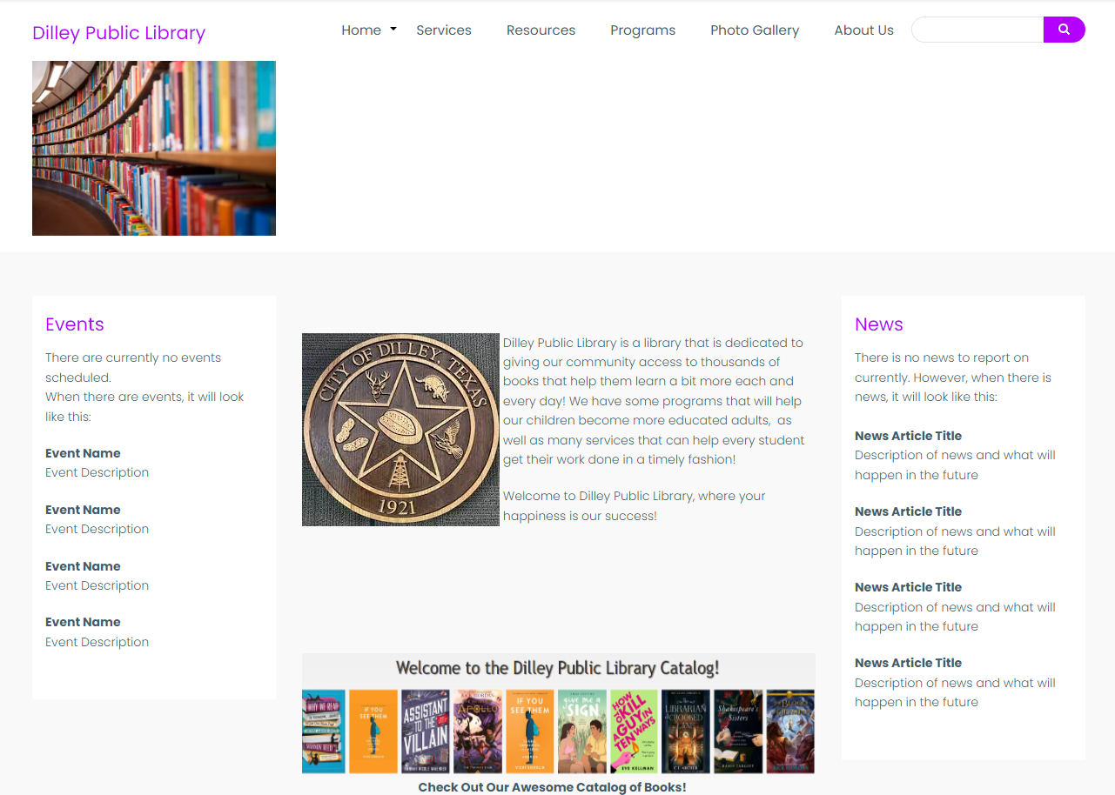

Services Page

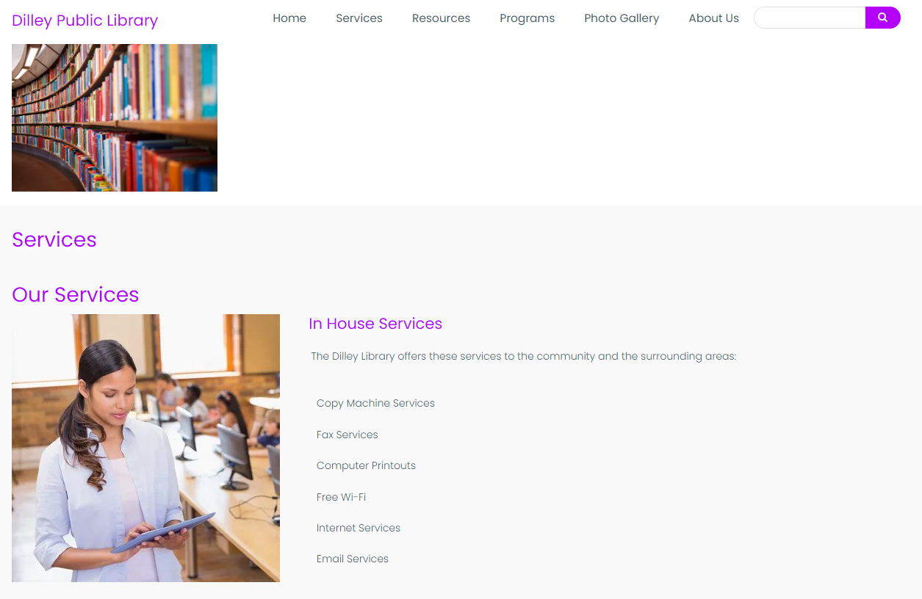

Photo Gallery Page

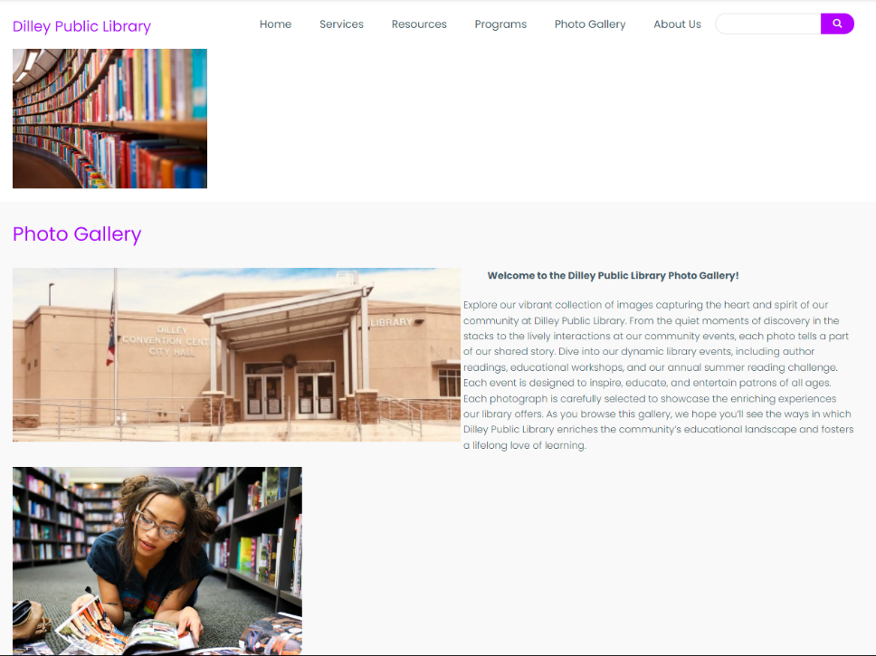

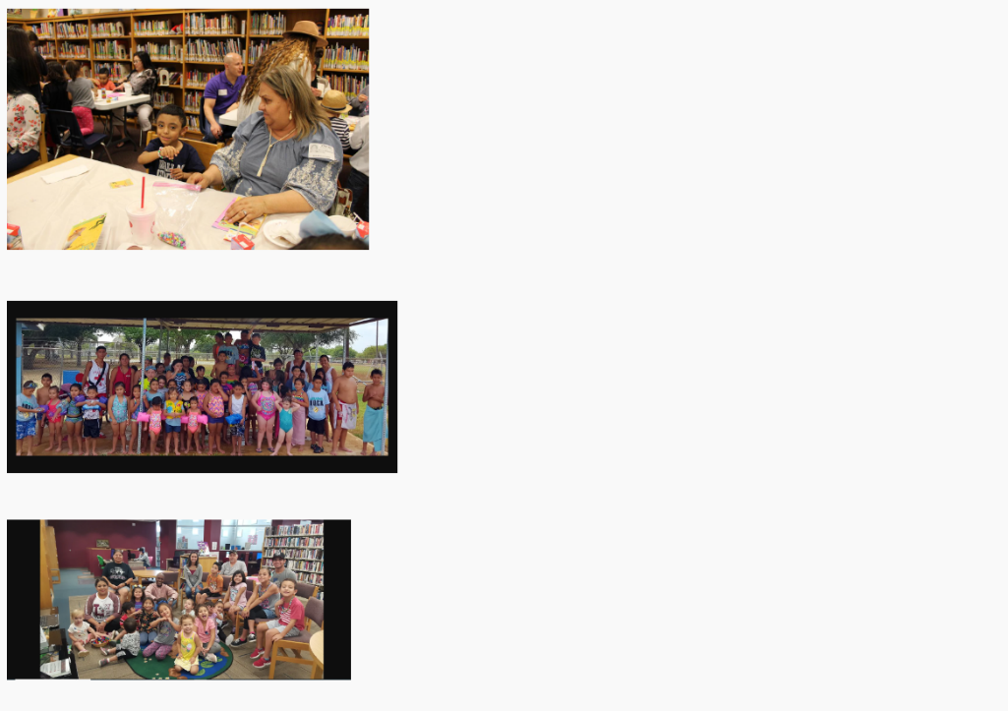

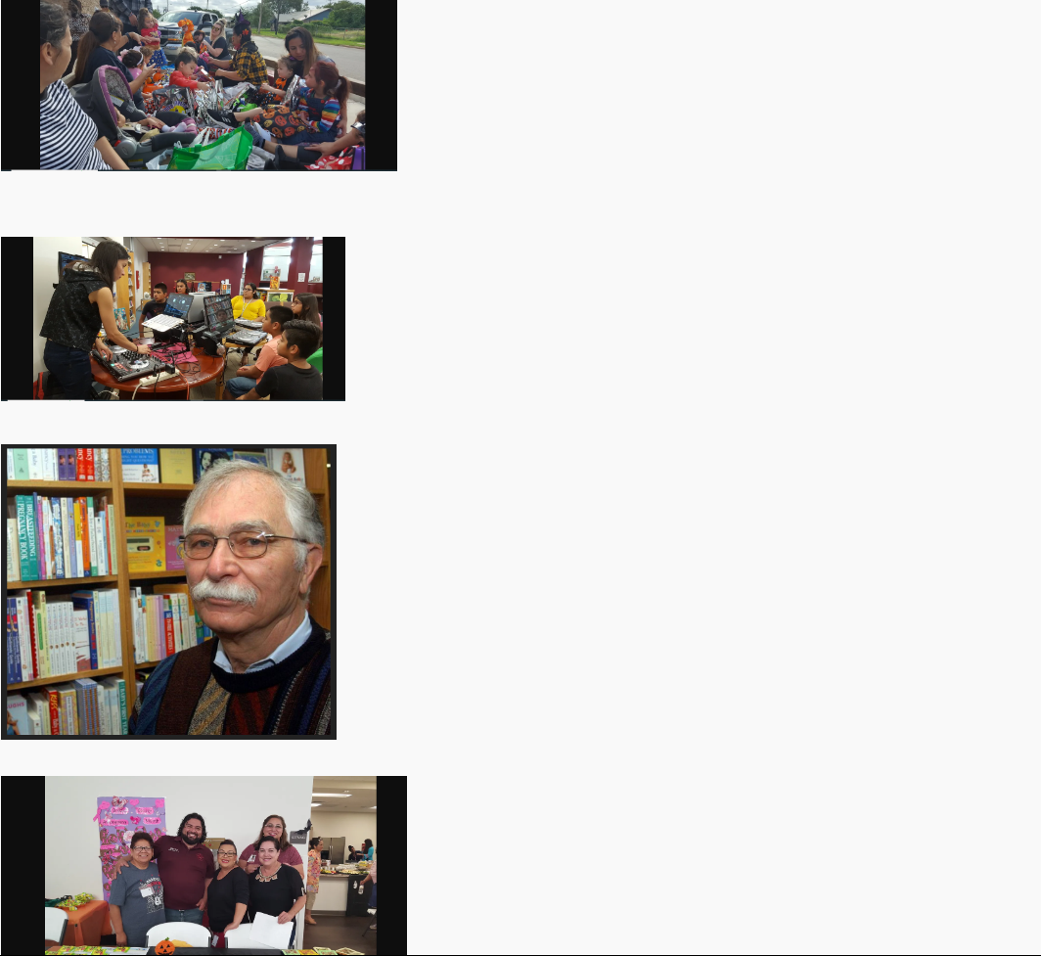

Footer

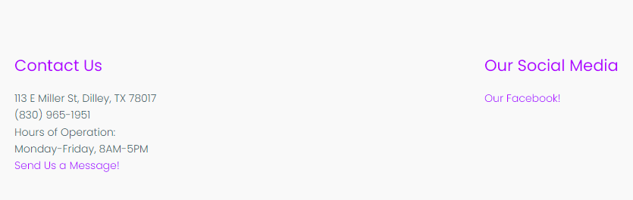

Search Page (Returned Keyword)

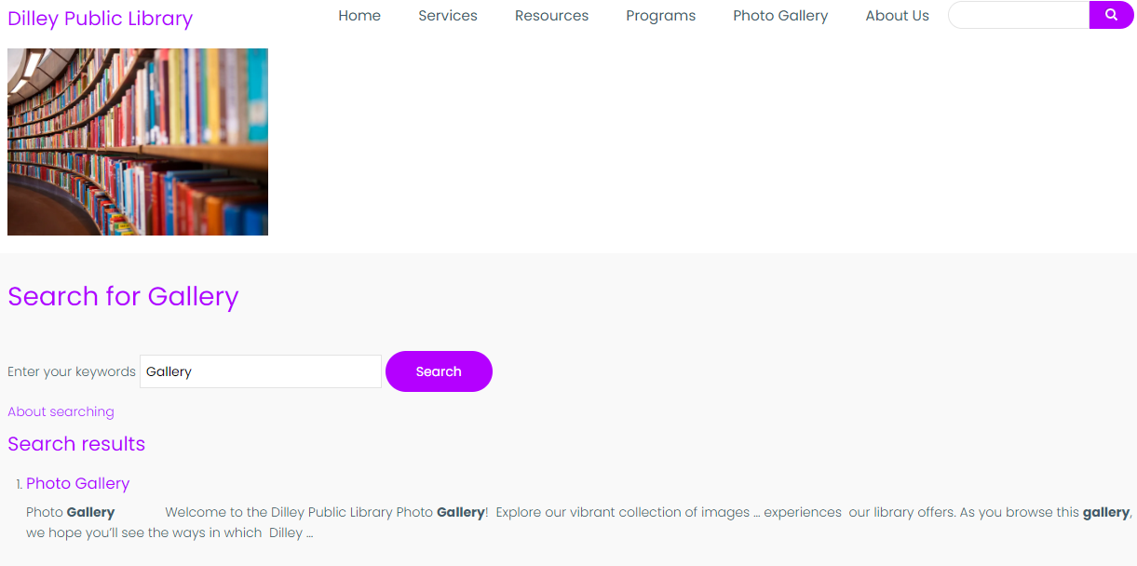

Search Page (Failed Search)

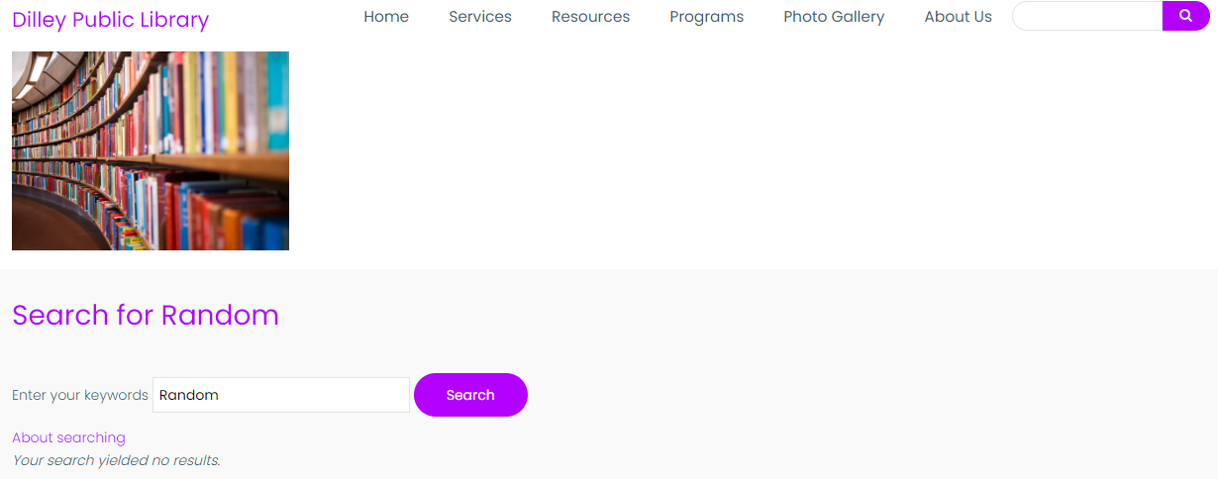

Contact Us Form

